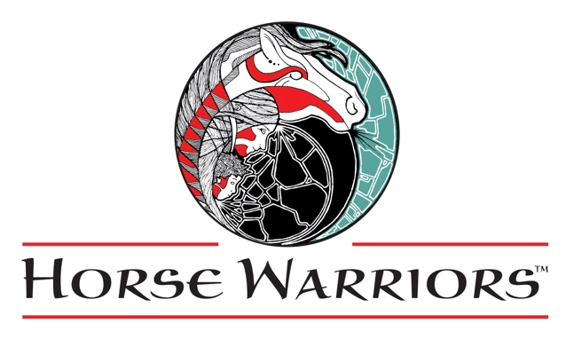

Board

David Chavez, President

Sherri Renzulli, Vice-President

Andrea Overly, Secretary

Coleen Regan

Lesley WIlliams-Gomez

Instructional Staff

Priscilla Marden, CEIP-ED; CTRI; ESMHL

Executive Director; PATH

Certified Instructor; Equine

Specialist in Mental Health &

Learning;

Certified Equine Interaction

Professional/Education

Nancy Waite-O’Brien, Ph.D.;

Licensed Psychologist;

CEIP-MH; SEP; Visiting

Instructor

Sarah Worcester; PATH Certified

Instructor

RyLyn Lippold; HW Graduate

Staff Therapists

Courtney Marvin, LMFT

Sherri Renzulli, WYLAC

Volunteers

Karen Eckert

Trudy Funk

Samantha LaBounta

The Olenslager Family

Tony Panarisi

Patti Rooney

Trish & Rich Sherman

Maria Sloan

KO Strohbehn

Elizabeth Sword

Suzette Welch

Board

David Chavez, President

Cheryl Renzulli, Vice-President

Lisa Capps, Secretary

Coleen Regan

Instructional Staff

Priscilla Marden, CEIP-ED; CTRI; ESMHL

Executive Director; PATH

Certified Instructor; Equine

Specialist in Mental Health &

Learning; Certified Equine

Interaction Professional/Education

Nancy Waite-O’Brien, Ph.D.;

Licensed Psychologist;

CEIP-MH; SEP; Visiting

Instructor

Grace Carlson; Junior Staff

Staff Therapist

Cheryl Renzulli, WYLAT

Volunteers

Lisa & Scott Capps

Karen Eckert

Steve Harrington

Samantha LaBounta

Jennifer Nield

Tony Panarisi

Patti Rooney

Corinne & Brett Storey

Elizabeth Sword

2022 EAAT Residency Application

Intention: Prepare candidates for professional employment

Dates: April 1 – September 30, 2021

Location: Diamondfly Ranch, Thayne, WY (Jackson Hole area)

Program Venues: Diamondfly Ranch (Star Valley Wyoming);

Wilson Arena (Wilson, WY); Grand Teton National Park and Bridger-Teton National Forest (Jackson Hole); Caribou National Forest (Idaho); Wyoming Range (Star Valley); TC Fairgrounds (Jackson, WY)

Compensation: $1500/mo. stipend; On-site bunkhouse lodging (2-bedroom, 1 bath, kitchen - shared occasionally during our residential programs and practicum student residencies); Practicum supervision hours/evaluation for current grad students; certification hours for CEIP

**PLEASE VIEW VIDEO TO SEE FACILITIES:**

<https://www.youtube.com/watch?feature=player_embedded&v=0RyVNQOtOfw>

Work Duties: (this is all about teamwork – we ALL do it ALL here!)

1. Assist with all programs in the arena and out on the trail – instruction responsibilities will depend on experience
2. Assist with horse care, feeding, exercising
3. Assist with ranch chores including daily corral cleaning, fence repair, pasture transport, barnyard and arena cleanliness, equipment maintenance, maintaining pleasant, welcoming ranch atmosphere
4. Participate in HW fundraisers and special events
5. Assist with curriculum planning and summer program logistics
6. Participate in weekly staff meetings

Requirements: **SAFETY CONSCIOUS TEAM PLAYER** – first and foremost

* 21 and over (insurance requirement)
* hard-working (we work long hours, 5-6 days/week, with all the transportation between venues – some days are 14-hour days)
* positive, polite, cheerful attitude with a healthy sense of humor
* must love working with kids age 6-18, with a majority in middle school
* excellent horse management and riding skills – must be able to ride every one of our horses (14h – 16h, beginner to advanced)
* backcountry trail riding experience a strong preference
* excellent physical fitness with no prior injuries/allergies that would limit function or ability to do ranch work; lift heavy saddles, move 90 lb. hay bales
* strong self-awareness and ability to leave personal issues out of the work environment
* desire to make a positive difference in the world
* professional appearance/appropriate dress at all times
* sorry, no pets – we have plenty here already

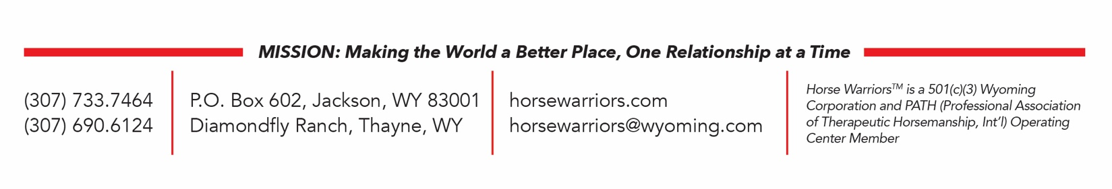

Overview of Youth Programs

Horse Warriors™ is an Equine Facilitated Mental Health and Learning program designed to empower youth, families and women. Begun in 1998, it has served over 500 individual students, the majority of who stay in the program 5-7 years. Our clientele is traditionally described as "at-risk," though we no longer use that term, preferring to focus on leadership and empowerment as descriptors of outcomes, not focusing on labels. They are referred to us by social service agencies, mental health professionals, school counselors, teachers, pastors, juvenile advocates and pediatricians. Art and writing are integral parts of all the Horse Warriors™ programs. Arts curricula include creative writing, journaling, drawing, and painting. Program goals include helping students learn to make healthy, life-affirming choices, develop safe relationships, become employable, graduate from high school and preferably enter college or trade school. Students are taught to respect themselves and others, recognize an intrinsic value of life in all living things, to live with compassion, and give back to their communities.

Our youth programs are sequential programs that allow students to participate over multiple years. During those years they use their journals and art projects to help ground their experiences. They are each provided with an art kit to use at the arena and out on the trail, and also during the school year retreats they attend with their riding groups. Kits contain unlined journals, a travel case to keep supplies together in saddlebags while out on the trail, colored pencils, Micron pens, graphite pencils, stumps, white erasers, scissors, pencil sharpeners, gel pens, splenders (colored pencil blenders), zipper pouch for holding pens, ziploc bags to keep journals dry and a baggie for pencil shavings. Ranch based winter projects include many 3-dimensional projects such as mask-making, clock painting, boot jacks, furniture painting, zentangles and artistic cooking/food presentation.

School-age students are from Teton and Lincoln Counties, WY. All of our programs are full each year with waiting lists. 80% of students are from broken homes, 60% of those are single parent households. 18-25% have had incarcerated parents. 60% have histories of substance abuse or self-destructive behaviors. Student age ranges are 6-18, with accompanying parents or guardians. Our oldest participant is 70 (caretaking grandparent). Our programs address the decline in family communication prevalent in our society, as well as the lack of adequate parenting skills evidenced by the increase in juvenile confrontations with law enforcement. They involve helping youth find healthy ways to express and conduct themselves. We include the parents/guardians of each student in interactive, equine-based learning and therapy programs. Mentoring, whether peer-to-peer, instructor to student, or volunteer to participant, is one of the great keys to success in our programs. One of the unique aspects of our programs is that we retain students for multiple years, making our impact extremely significant. We help youth and their families make real and lasting change. Our students are both able bodied and disabled. Disabilities in students include, but are not limited to:

* ADD/ADHD * Substance Abuse * Cutting * Asperger's * Developmental Delays * Learning Disabilities * Eating Disorders * Emotional Disorders * Antisocial behaviors * Hearing Loss * Anger Management * Sexual Abuse/PTSD * Amputees * Family Violence * Self-esteem issues

The Horse Warriors™ curriculum includes groundwork, equine communication, natural horsemanship, riding bareback, riding with saddles, obstacles, games on horseback, extensive journaling/art/creative writing instruction, trail riding, environmental awareness, peer mentoring, discussion groups, community service, academic tutoring, school-to-careers assistance, parenting instruction, family interaction days with horses, gymkhana, Demo Team, public speaking presentations, annual newsletter/magazine featuring student writing and artwork, horse care and stable management. Horse Warriors™ programs are year-round; Power Ponies™ and Mighty Mustangs™ are summer parenting programs, building sequentially and having students progress through the programs year after year. Group sizes at Horse Warriors™ are 4 students/group, and are based on riding ability and peer maturity levels. Power Ponies™ classes involve 4-5 families per section (parent/child combination, along with a Horse Warriors™ mentor and an adult horse supervisor). Mighty Mustangs™ classes have 5-6 participants per section. Groups are designed to be small to promote intimacy and maximize the amount of 1:1 staff/student interaction. The average number of family program students served in any calendar year is 50-70.

**APPLICATION PAGE**

Please answer the following questions on a separate sheet of paper. These questions are designed to give you the opportunity to describe yourself in detail, as well as to give us a sense of appropriate fit. Our programs are 85% fun and 15%, *“WHAT??? Can you believe that just happened???*” The ideal candidate is going to be someone who can be simultaneously creative and flexible, keeping the big picture in mind.

We are a teaching facility, here to help you learn, so we do not expect you to know everything there is to know before applying for an internship! These questions give us guidelines for consideration. This is a non-smoking environment, and though it probably goes without saying we will say it anyway – if you have a history of alcohol or substance abuse this would not be the place to work. We also have a squeaky-clean language policy – we are working with kids, we are role models and we are careful about how we use our words. We employ these guidelines with our students as well.

Name:

Address:

E-mail:

Phone:

Age:

Education level:

School affiliation (if you have one):

1. Why are you interested in an internship with Horse Warriors™?
2. What is your background with horses? Please be very specific – include types of instruction you have had in your life, riding experience/disciplines, types of horses you have worked with, how you handle horses, what your philosophies are about training – how have those evolved throughout your experience?
3. What is your background with working with children? Please include venues, age groups, subject matter, anecdotal experiences.
4. What is your experience in being out on the trail in a variety of weather conditions? What about encounters with wildlife (deer, elk, bears, bison)?
5. How would you describe yourself to someone who doesn’t know you at all on your best ***and*** worst days?
6. Please describe your level of patience and what your limits are – this is very important as some of our students have challenges that can trigger lots of “stuff”.
7. What is your level of fitness/endurance? This is important as this is a very active job with a lot of moving horses, equipment, feed, etc. If a horse loses a shoe you might have to walk 6 miles out of the backcountry (it has happened!).
8. How would you describe the concepts of “hard work” and “team player”?
9. What do you feel would be your ideal job in this field of EAAT? Project yourself 5 years into the future – where do you want to be?
10. Please provide a list of 5 references from people who know you well and are not relatives, personal and professional, with daytime phone numbers and emails so we can easily contact them. Please give them a heads-up that we will contact them (we always do!).